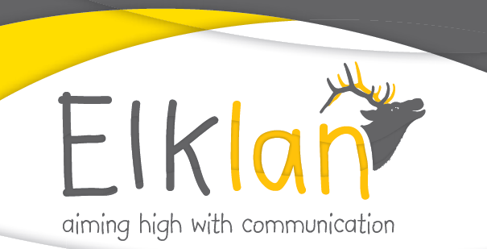 | 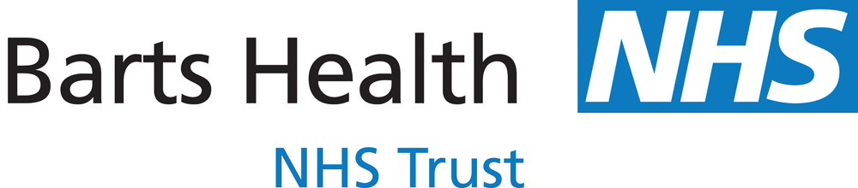  Speech and Language Therapy Children’s Service | 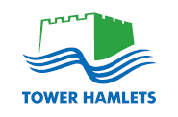  Support for Learning Service Language and Communication Team
Speech and Language Support for 5-11s
10 week accredited course for Primary School Staff
Autumn Term 2013
Trainers: James Dodd (Children’s Speech and Language Therapy)
and Tracey Grant (Language and Communication Team)
Feedback from students on the course in Tower Hamlets:
“I feel much more confident now ... as I know how to identify barriers and then how to support children.”
“Learning the processes that a child needs to understand is amazing and has made me rethink the way I communicate with all children.”
“The course helped me to understand much better the concept of speech and language. Now I can better organize my lessons according to the child’s needs”
Course Aims:
The national course is suitable for all staff working in Primary Schools who wish to develop their confidence and skills in supporting children with speech, language and communication needs (SLCN). It is often recommended in statements of special educational need.
Course Structure:
- 10 weekly 2 hour taught sessions at Mile End Hospital
- additional portfolio work to gain accreditation; this will require an additional 4 hours of work per week outside the sessions e.g. running groups with children and writing up tasks.
Accreditation:
The course is accredited through apt awards (formally Open College Network South West). It is possible to gain accreditation at Level 2 or 3. Level 3 accreditation is registered on the QCF.
Cost:
£300 per participant which covers teaching, ongoing support to complete the portfolio, a Language Builders handbook and accreditation fees.
The next course will run:
Mondays 2.00-4.00 pm
from Monday 7th October 2013
Education Centre, Mile End Hospital E1 4DG
For more information on this Elklan courses visit www.elklan.co.uk/courses/practitioners/speech-and-language-support-for-5-11s
For information about course organisation in Tower Hamlets go to: http://en.commtap.org/events/elklan-5-11s-course
Elklan 5-11s Course Content (10 Sessions)

What is communication?
- Identify the processes involved in communication
- Appreciate the wide range of communication problems

Understanding non-verbal communication, listening, attention and using visual strategies
- Identify non-verbal communication behaviours
- Develop strategies to support children with poor listening and attention
- Encourage the development of independent learning skills and use of visual supports.

Developing memory skills
- Explore how memory works and ideas to support different learning styles
- Use of mind mapping in the classroom
- Develop activities to facilitate the learning of linguistic concepts

Modifying adult's speech to help a child understand language
- Use the technique of Information Carrying Words (ICW's).
- Make listening activities harder/easier to ensure flexibility in meeting individual needs.

Understanding beyond simple sentences
- Use a language scheme model which supports verbal reasoning skills, including why and how questions, inferences, sequencing, predicting

Promoting Vocabulary Development
- Understand how children learn new words.
- Develop a range of strategies to support the learning and retention of new words.

Encouraging expressive language
- Identify the processes involved in expressive language.
- Learn techniques to develop syntax (grammar) and narrative skills

Promoting effective communication & social skills
- Reflect on the effects that interaction patterns have on communication.
- Identify skills required for successful social communication.

Supporting children with unclear speech and exploring the link between speech, reading and writing
- Know the development of speech sounds
- Develop strategies to support children with unclear speech
- Consider the link between speech, reading and writing.

Management of stammering and application of all strategies learnt
- Share ideas to support children who stammer
- Make a poster to present evidence of applying knowledge during classroom activities
 | Speech and Language Therapy Children’s Service | Support for Learning Service Language and Communication Team
ELKLAN Speech and Language Support in the Classroom (Autumn 2013)
Training Course Application Form
Dates: 10 Monday afternoons from 7th October onwards
Time: 2.00 – 4.00 p.m.
Location: Mile End Hospital
School:
Number of places required
Total Cost to School:
£300 for each participant.
There will be a reduction of approximately £50 for students who do not wish to gain the accreditation.
Purchase Order Number (if available)
Name of Authorised Budget Holder:
Signature of Authorised Budget Holder:
Address for Invoice:

Please return this form to:
James Dodd
Children’s Speech and Language Therapy Service
Hastings Ward, Mile End Hospital,
Bancroft Road
London E1 4DG
or go to: http://en.commtap.org/events/elklan-5-11s-course

